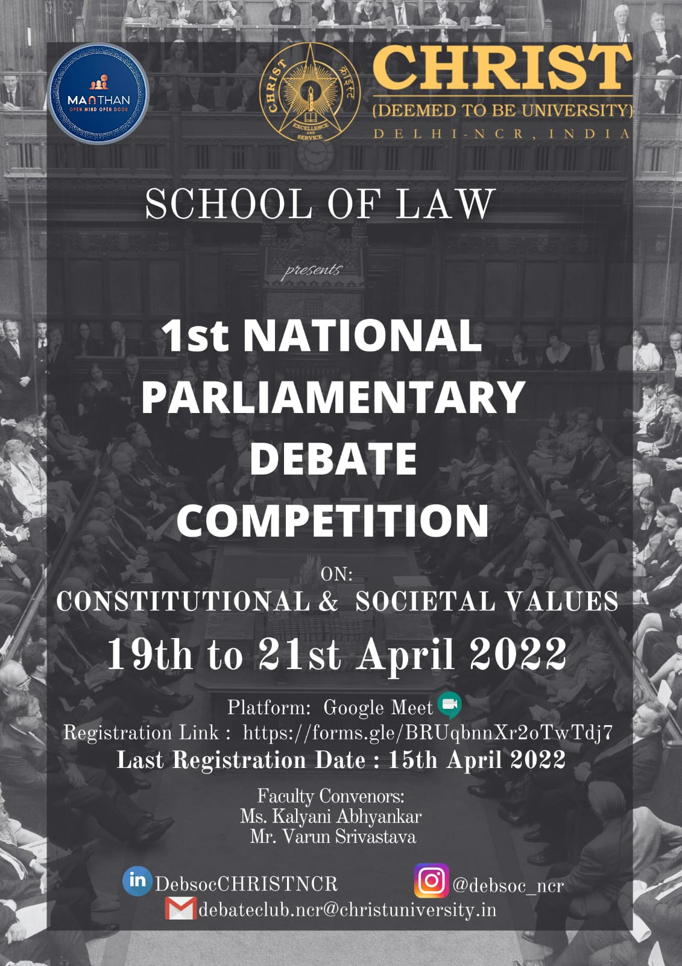
ABOUT CHRIST (DEEMED TO BE UNIVERSITY), DELHI-NCR:

CHRIST (Deemed to be University), Delhi-NCR was born out of the educational vision of St Kuriakose Elias Chavara, an educationalist and social reformer of the nineteenth century in South India. He founded the first Catholic indigenous congregation, Carmelites of Mary Immaculate (CMI), in 1831, which administers CHRIST (Deemed to be University), Delhi-NCR. Established in 1969 as CHRIST College, it undertook path-breaking initiatives in Indian higher education with the introduction of innovative and modern curricula, insistence on academic discipline, imparting of Holistic Education and adoption of global higher education practices with the support of creative and dedicated staff. The University Grants Commission (UGC) of India conferred Autonomy to CHRIST College in 2004 and identified it as an Institution with Potential for Excellence in 2006.

In 2008 under Section 3 of the UGC Act, 1956, the Ministry of Human Resource Development of the Government of India, declared the institution a Deemed to be University, in the name and style of CHRIST University. One of the first institutions in India to be accredited in 1998 by the NAAC, and subsequently in 2004 and 2016, CHRIST (Deemed to be University), Delhi NCR has the top grade 'A' in the 4-point scale. The multi-disciplinary University which focuses on teaching research and service, offers Bachelors to Doctoral programmes in humanities, social sciences, science, commerce, management, engineering, education, and law to over 21000 students.

The campus is a living example for the harmonious multiculturalism with students from all the states of India and around 60 different countries. CHRIST (Deemed to be University), Delhi-NCR publishes six peer-reviewed research journals and has published more than 300 books in Kannada and English. A promoter of sports, music and literary activities, it is a nurturing ground for creative excellence.

ABOUT SCHOOL OF LAW

The School of Law offers B.A. LL.B., BBA. LL.B., LL.M. and Ph.D. in Law. It has a flexible curriculum offering several options in different areas of specialization. It is devised keeping in mind the requirements of legal profession and academia. The programmes offered at the School of Law incorporate a number of special opportunities such as internships, clinical programme, supervisory research and writing. In order to promote interaction between students and legal professionals, seminars, guest lectures and workshops are conducted on various subjects of law on regular intervals. In addition to the mandatory courses spanning across a ten-semester programme, the School of Law has also introduced numerous other value-added courses and programmes for the benefit of students. The School of Law, CHRIST (Deemed to be University), Delhi-NCR has made a name for itself in a very short span, because of its vision and focus on
- Interdisciplinary holistic and dynamic approach to learning
- Continuous industry-academia institution interface
- Innovative learning methods are adopted
- Opportunity for students to attend internships with renowned advocates, judges and law firms.
- Opportunity to interact with faculties from foreign universities Inculcating social
- responsibility in students through village visits and working with NGOs

SCHOOL OF LAW, CHRIST (DEEMED TO BE UNIVERSITY),DELHI- NCR Under the aegis of

MANTHAN

SCHOOL OF LAW’S DEBATE SOCIETY

“MANTHAN” the debate society of CHRIST(Deemed to be University),Delhi-NCR is taken up by like-minded individuals, aiming to deliver knowledge on various contemporary issues along with some basic insight in law which is quite crucial in days to come. After diagnosing the need for virtual education through well researched blogs and articles, we have worked towards establishing a platform that will serve students and professionals in various ways some of which we have started to achieve. At CHRIST we work together for service and excellence likewise the debate club of this university is working on imparting knowledge and aptitude. By getting associated with us students gain holistic skills in the parlance of legal profession, be it debates, or research and academics we deliver grooming in all aspects of the academic life.

COMPETITION BRIEF:

“वादेवादेजायतेतत्त्वबोध”
Truth is discovered and assimilated or realized by debates and discussions - Ancient Indian Philosophy of Vadashastra.

Under Covid Crisis, students and future lawmakers today are facing an unprecedented challenge in terms of confidence in public speaking, extra-curricular activities and building up their CVs. But the pandemic has also forged such intense technological revolutions which otherwise could have taken a long time to occur. The continuous revolution in this particular domain along with the data and social media platforms has given birth to many opportunities which one can avail from their homes with just the right click.
One such click is to register yourself with Manthan the debate society, Christ School of law, Delhi NCR which is putting in sincere efforts to provide an edge to post covid-19 CVs of as many as possible students and we hope, that the bond we create during the process, sustains forever.
In lieu of the same we proudly announce that MANTHAN the debate society of CHRIST (Deemed to be University), Delhi-NCR is all set to host its 1st National Parliamentary Debate Competition. The debate shall be conducted on 19th, 20th & 21st April 2022. (10:00 am – 4:30 pm IST). This shall act as a bridge between those who seek to express their views on issues of National Importance and enhance their debating skills and professionals out there who wish to get in touch with such dedicated scholars. This shall surely give every participant an edge by adding to their achievements even in such challenging times.

PARLIAMENTARY DEBATE:

We believe that there isn't a single "correct" way to do parliamentary debates. We wish to propagate that success at the national level in both high school and college, parliamentary debaters come through a holistic set of skills developed over the period by the debaters. They must master the art of reading well between the lines and adjust quickly in the heat of the moment which occurs many times in between the competition where both the teams give everything to ace the arguments and motions as well as to put the opponent team in a tough spot. The parliamentary debate aims to enrich students with knowledge regarding certain grey areas of constitutional law, this debate aims to have a deep and sound discussions on certain constitutional law topics which are disputable. The 3v3 format of the debate enriches students with the important aspects of teamwork and people management. This format of debate puts a student’s knowledge about a certain topic to test, at the same time giving them huge value of experience and content as they listen to other teams arguing their motion.
If you are looking forward to getting acquainted with the parlance of the debate, we would suggest you make the most of our venture. By emphasizing a liberal education approach to debate, where breadth of knowledge is placed at a premium, at MANTHAN, we take a student’s passion for debate and argumentation, and use it in order to teach them life skills such as effective presentation, critical thinking skills, and research in an academic setting.
Parliamentary debate offers students a unique opportunity to master a broad range of valuable skills – critical thinking, persuasive public speaking & knowledge of world affairs – that will help them succeed in the classroom & in the “real world” of business, government, and community.

ELIGIBILITY
- The competition is open to all the undergraduates/postgraduates’ students affiliated to any recognized university/institution.
- By applying for the competition, the teams shall be deemed to have accepted the terms and conditions of the organizing committee.

TEAM COMPOSITION

There two opposing teams in an Asians format of debate:
- Government side- proposes and defends the motion.
- Opposition side- refute and negates the motion.
- Each side is composed of three members.

The Members of the government side are the following:

- Prime minister (PM)- opens the debate, defines the motion and advances arguments.
- Deputy prime Minister (DPM)- refute at first instance the case of the opposition, reestablish the government’s claim, and advances arguments.
- Government whip (GW)- makes an issue-based rebuttal of the opposition’s case and
- summarizes the case of the government.

The Members of the Opposition side are the following:

- Leader of the Opposition (LO)- responds directly to the case of the government by giving a direct clash, and advances arguments. May challenge the motion if the definition is challengeable.
- Deputy Leader of the Opposition (DPL)- refutes the case of the DPM, reestablishes the case of the opposition and advances an argument.
- Opposition Whip (OW)- makes an issues-based rebuttal of the government’s and summarizes the case of the opposition.

Once registrations are done, no changes in names will be possible and the fees will be non – refundable. However, in exceptional circumstances, even if a change is inevitable, it shall be left at the discretion of the organizing committee.

RULES & REGULATIONS

PREPARATION
- Debate will take place via Google Meet.
- Teams shall be consisting of 3 members only.
- The respective motions for the teams in the prelims round will be released a night prior.
- The respective motions for the teams in the semi-final round will be released two hours prior.
- The respective motions for the teams in the final round will be released 30 minutes prior.
- Teams are requested to keep their video “on” while preparing.
- Teams must prepare on their own. Once motions have been released, there must be no contact between debaters in a particular team. failing to arrive in time for the debate will forfeit that particular round.
- Use of foul language during debate will result in disqualification of the candidate.
- Candidates are required to have a proper internet connection, failing which will result in the disqualification of the candidate.
- If a violation of the rules is believed to have been committed by a team or one of its members, the organizing committee may in its own discretion, upon its initiative or complaint from another team or assessor, impose a penalty or disqualify the team.
- There will be two preliminary rounds where each team will get opportunity to represent both government and opposition. Rest of the rounds are knockout rounds.

TIME OF SPEECHES:

Each speaker is allocated seven minutes to deliver their constructive speeches. One speaker from each side (For the Government: PM/DPM, for Opposition: LO/DLO) is given four minutes to deliver a reply to speech. Substantive Speeches: 6 + 1 minutes (each), The speakers will be speaking in the following order:
- Prime Minister
- Leader of the opposition
- Deputy Prime Minister
- Deputy Leader of the Opposition
- Government Whip
- Opposition whip
- Opposition Reply
- Government Reply

During the constructive speeches, Point of Information (POI) may be raised by the opposing side after the first minute up to the sixth minute. POI may be refused or accepted by the speaker.
During reply to speeches, no POI may be raised.

Reply Speech:

Reply speech is a comparative analysis of the strength and weaknesses of the case of both sides.
The aim of the speech is to give a bias judgment as to why should the people support the team’s claim. The speech is first delivered by the opposition side and followed by the government side who will close the debate.

SPEAKER ROLES IN ASIAN PARLIAMENTARY DEBATE

Government:

Prime Minister (PM)

Define context and parameters of debate. For example, in an open motion like “This House
Would Support Musicians”, the debate could be contextualized into whether music should be a commodity for trade, or it should be available gratis ( i.e., free music download and transfer)
- Provide concise background or history leading to the issue
- Give framework of government bench’s case. I.e. mechanisms (if any), argumentation flow (what the government’s first argument is and what the Deputy Prime Minister will talk about)
- Introduce 1st argument
- Assert Government stand

Deputy Prime Minister (DPM)

- Rebut first argument from Leader of Opposition
- Rebut rebuttals to PM’s argument
- Introduce 2nd and 3rd argument
- Reassert Government stand and case

Government Whip

- Rebut Deputy Leader of Opposition, and Leader of Opposition
- Rebut rebuttals to DPM and PM arguments
- Provide a deeper level of analysis for previous arguments and rebuttals
- No new arguments, but new angles of arguments should be given  Summary of entire case of Government.
- Reassert Government stand and case opposition.

Opposition:

Leader of Opposition

- Agree or disagree with context/ parameters of debate (any definitional challenges, accusations of squirreling, or unfair set up should be made from the LO speech and no later)
- Rebut Prime Minister’s argument
- Give framework for Opposition case (if Opp agrees to problem, then their case should provide solution, or at least effectively highlight how Government proposal will worsen the situation)
- Introduce first Opposition argument
- Assert Opposition stand

Deputy Leader of Opposition

- Rebut DPM and PM arguments
- Rebut rebuttals to LO arguments
- Introduce 1st and 2nd (if any) argument
- Reassert Opposition stand and case

Opposition Whip:

- Rebut DPM and PM arguments
- Rebut rebuttals to LO & DLO arguments
- Provide a deeper level of analysis for previous arguments and rebuttals
- No new arguments, but new angles of arguments should be given
- Reassert Opposition stand and case

Reply Speech:

- Can only be done by either 1st or 2nd speaker from each bench
- Provide a biased ‘oral adjudication’ of why the debate should go to own bench
- Highlight issues you think your side won, carefully tiptoe around issues you think you lost .
- New examples to expand on discussed examples is usually allowed and makes the reply speech sound fresh as opposed to verbal regurgitation
- Reassert stand.
THE DEBATE: TEAM ROLES

PROPOSITION:

- Support the motion and give a definition
- Realize the problem and propose a solution
- Provide model or mechanism
- Engage with opposite side
OPPOSITION:
- Go against the motion
- Realize the problem, but go against PROP’S proposal
- Provide counter model or alternative

GENERAL INSTRUCTIONS

- The dress code for the activity is western or Indian formals
- At any point of conflict, the decision of Host Organization Christ Deemed to be University Delhi NCR, will be final and participants have to follow the same.
- MANTHAN reserves the right to alter or change the rules or procedure of the competition any time before or during the competition.
- Details and information concerning the debate will be shared through Email and WhatsApp by the organizing committee.

REGISTRATION PROCESS:

    - Step1- Participants need to fill details in the Google Forms.

- Participants need to fill the Google form given below - https://forms.gle/BRUqbnnXr2oTwTdj7

- NOTE: Christ University students(All Campuses) participating need to fill the form below https://forms.gle/hwZZXLReoVqcZbqE6

    - Step 2- If the registration of Participants is being accepted, they will receive a confirmation mail to their registered Email address.
    - Step 3- The participants will have to pay the registration fees of Rs. 750 per person.

    - Step 4- After Successful Payment, participants will be informed about the same and they need to send the screen shot of the receipt of the payment through email.

REGISTRATION FEES

REGISTRATION FEES FOR EACH TEAM – Rs. 750 (Seven Hundred Fifty Rupees)

PAYMENT DETAILS

PAYMENT DETAILS FOR THE PARTICIPANTS :

REFER TO THE BELOW MENTIONED LINK FOR THE PAYMENT OF
REGISTRATION FEES-

Asian Parliamentary Debate Competition will be found under the FEST option, of the fee category
Click the link > “pay online button” >fest>Asian parliamentary debate competition

https://ncr.christuniversity.in/e-services-online-payment-portalncr

IMPORTANT DATES

- Registration opens: 31st March 2022
- Last date to register: 15th April 2022
- Date of event: 19th – 21st April 2022

REWARDS

  - Winner team: cash prize of Rs. 12000 & certificate of appreciation.
  - Runner up team: cash prize of Rs. 8000 & certificate of appreciation.
  - 2nd runner up team: cash prize of Rs. 2500 & certificate of appreciation.
  - Best Speaker: cash prize Rs. 2500 & certificate of appreciation.
  - Participation certificates to be given.

CONTACT US:

ISHAN VERMA (CONVENER) - 94980696600

ANANYA JAIN (CONVENER) - 7838683437

ANUSHKA DATTA (CO-CONVENER) - 7073744078

OR

MAIL TO: debateclub.ncr@christuniversity.in

